**Smart Energy Meter Portal – Design Approach**

Smart Energy meter portal basically aims at Customer to manage the bills, Consumption history etc. Admin user will use the portal to manage the Customers, registered Smart Energy meters etc. Lets Keep it simpler

**Customer Interface**:

1. Login screen

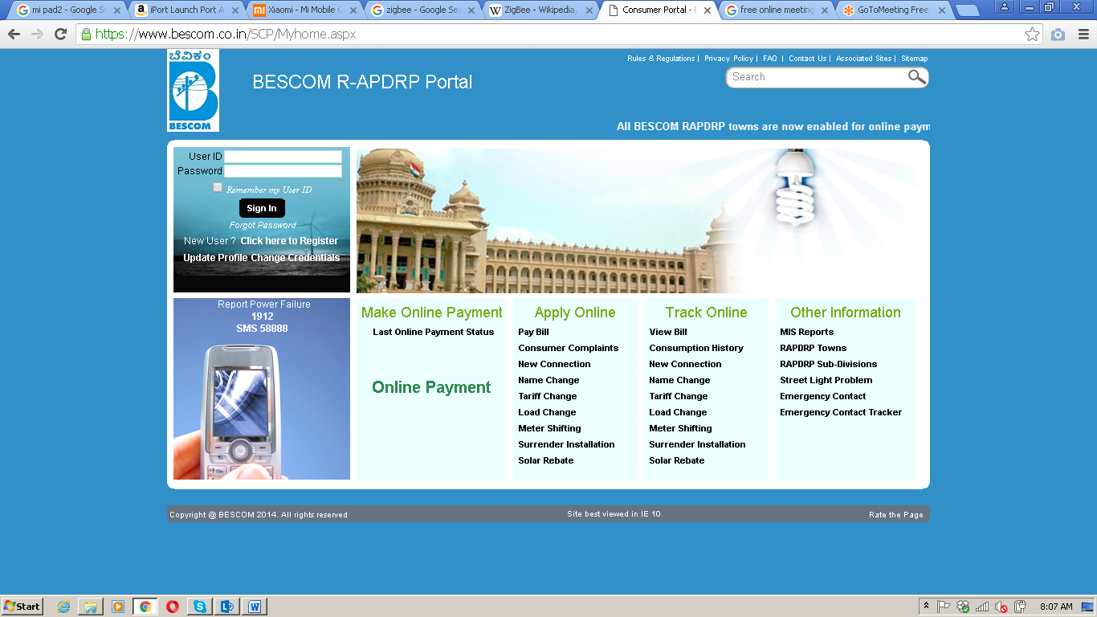

1. Customer Registration

* UserId
* Email
* Password
* Consifrm Password
* Mobile Number
* Account Id

1. Dashboards

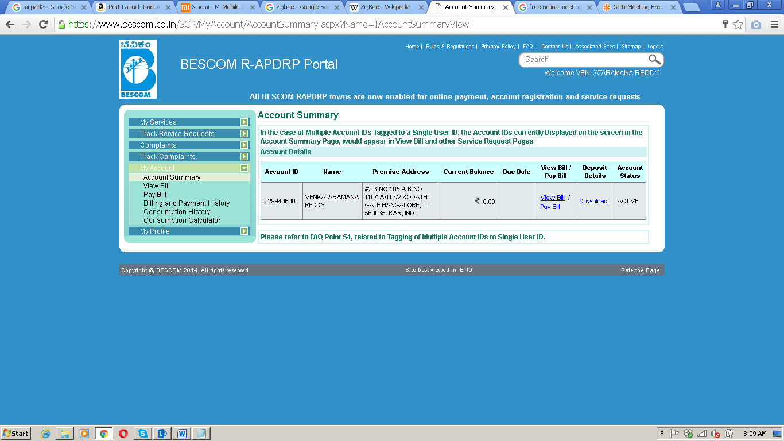

1. Consumption History

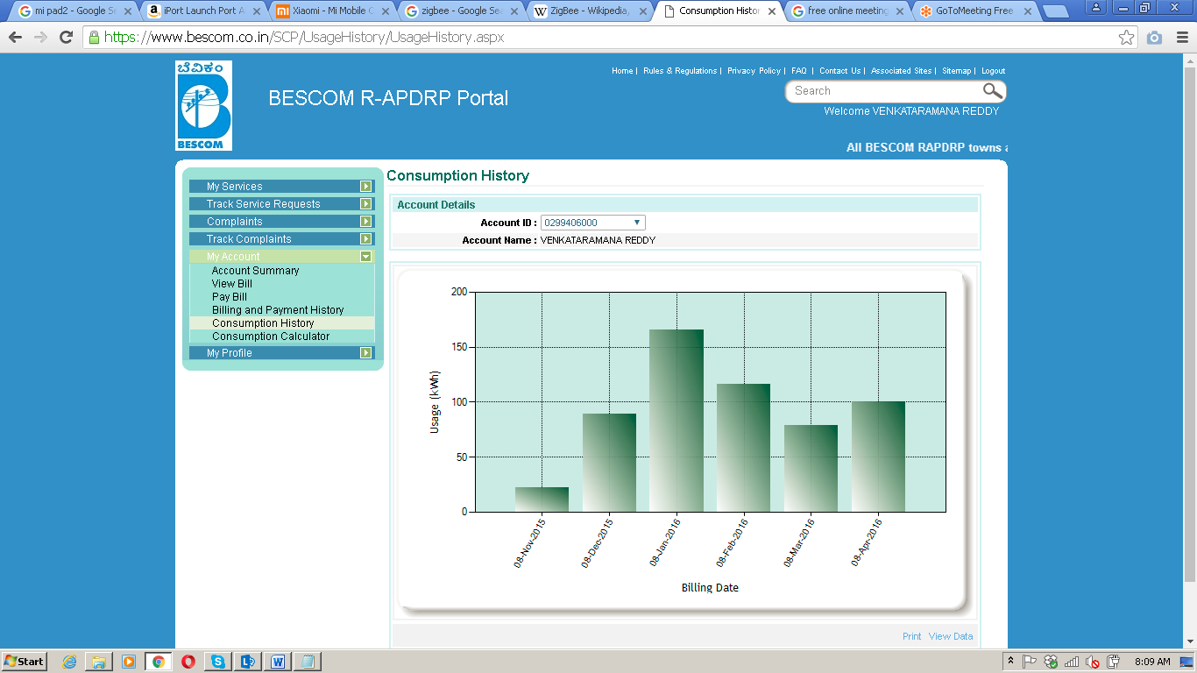

1. d

**Admin Interface**:

Admin interface will be slightly different to manage different Customers, Smart Energy Meters etc.

**Smart Energy Meter API Overview**

Smart Energy Meter API depicts the various End points exposed to devices to communicate with the Portal via Http protocol. For example we will have the following End points exposed to manage the consumption data

* [http://smartenergymeter/api/consumtion/{accountid}/{consumedunit}](http://smartenergymeter/api/consumtion/%7baccountid%7d/%7bconsumedunit%7d)

The above sample Http service should be invoked within the microcontroller and communicate via Wifi moidule

**Note:**

Ui shown above is just a sample I scratched from our Bangalore Electricity board portal ☺ This just acts as a prototype to refer to ease the development

**Technology stack:**

* ASP.Net MVC for the UI layer
* Web API for REST Http Service development
* SQL Server 2012 for Database